Additional File 1 – Supplement S1-S11

03 May 2024

Table of contents

# Additional File 1 - Supplement S1-S11

Supplementary information for the paper

*“Histology-specific standardized incidence ratio improves the estimation of second primary lung cancer risk”*

Authors: Eberl M, Tanaka LF, Kraywinkel K, Klug SJ

Correspondence: Marian Eberl, marian.eberl@tum.de, Chair of Epidemiology, TUM School of Medicine and Health, Technical University of Munich, Munich, Germany

## Table S1: Comparison of IARC/IACR and SEER multiple primary rules

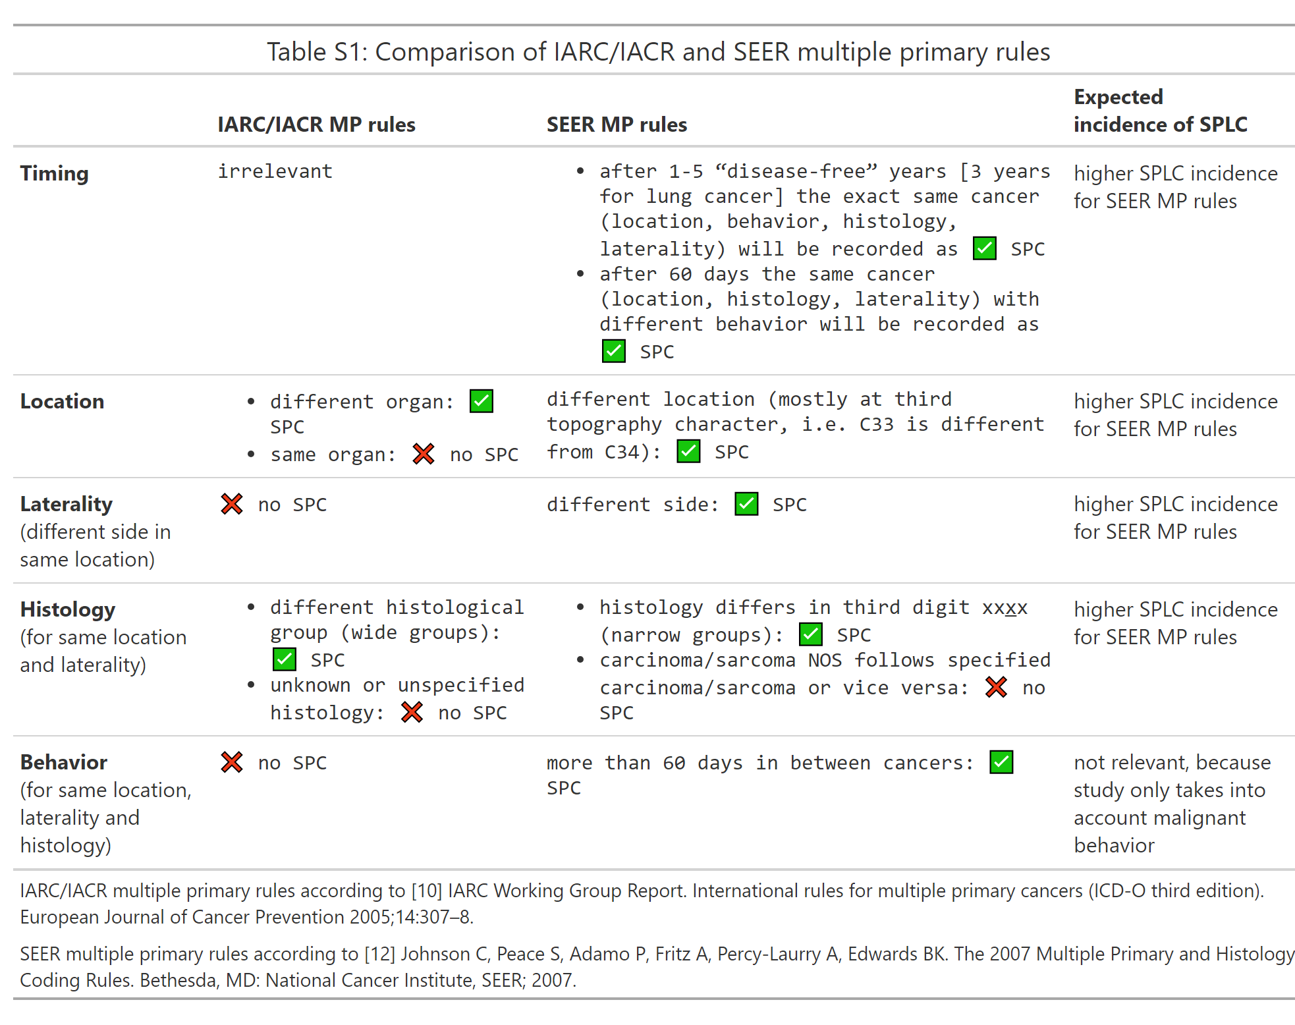

## Table S2: Details of dataset filtering

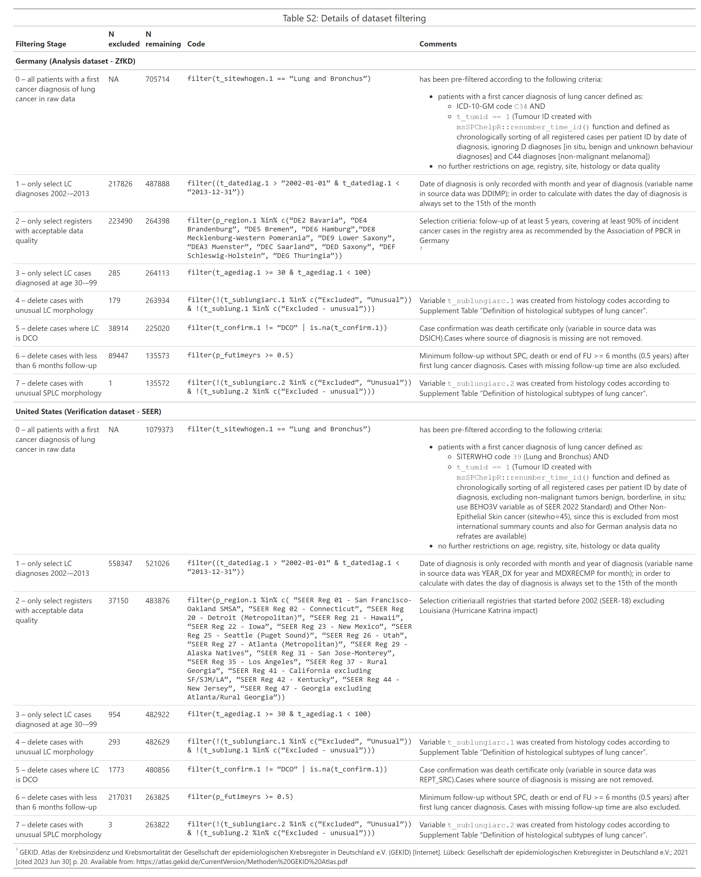

## Table S3: Details of data modifications

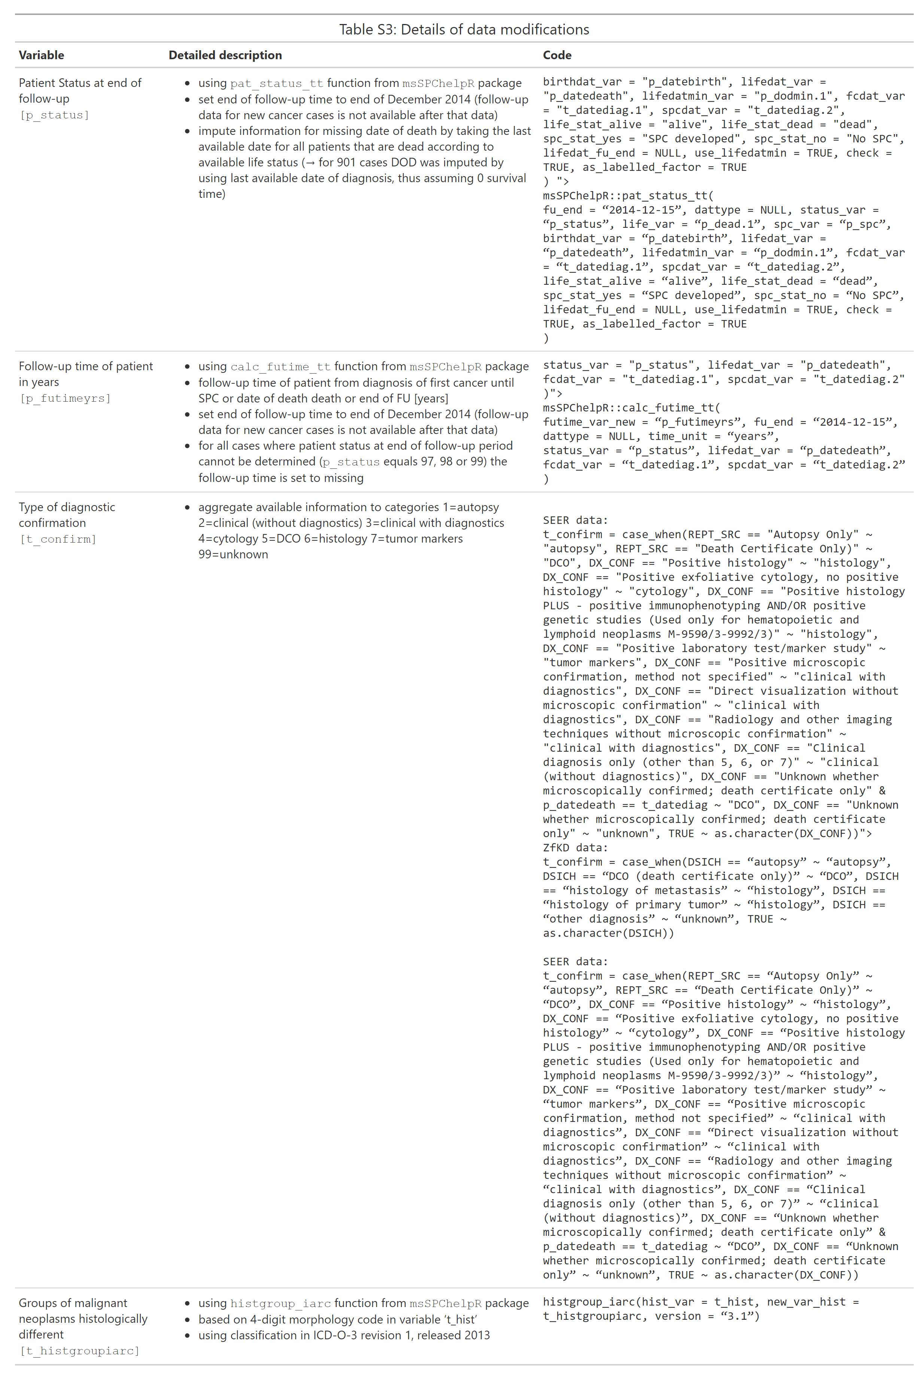

## Table S4: Data quality for included regions and SIR estimates

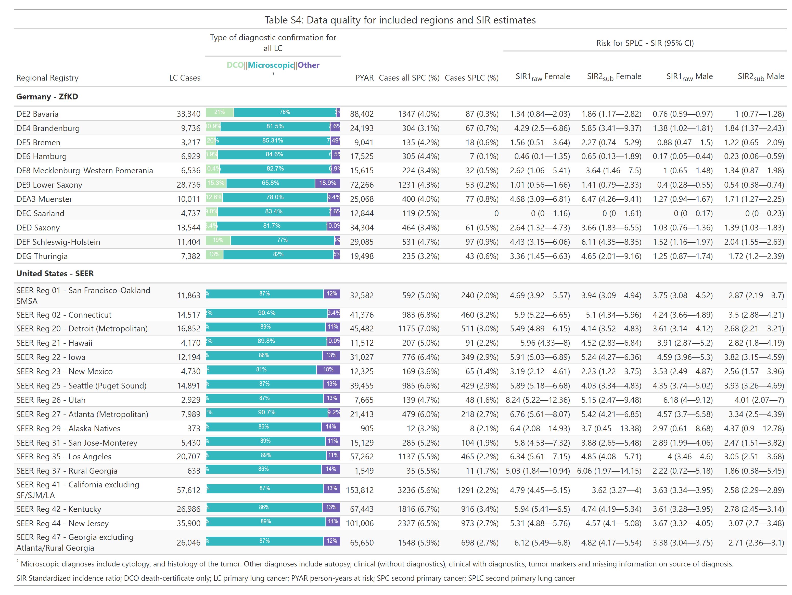

## Table S5: Conversion table of histology codes into ICD-O-3 histologically ‘different’ groups and histological subtypes of lung cancer

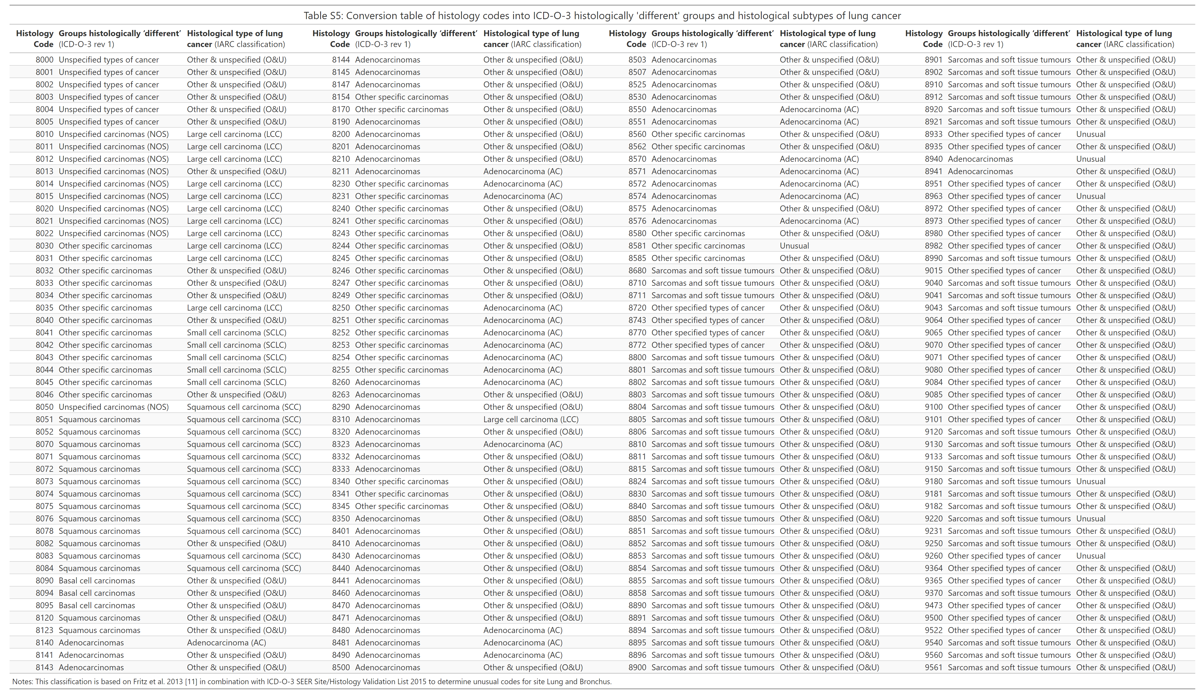

## Section S6: Details on simulations to estimate the size of bias using standard SIR

To estimate the size of bias introduced by using general population reference rates for calculating SIR of same-site SPC when IARC/IACR MP rules are applied, we simulate various scenarios. First, we assume that the baseline risk of LC survivors to develop an SPLC is the same as for the general population (real SIR = 1.0). We determined the proportions of histologically different LC groups ${p_{hist}}_{j}$ in the analysis dataset for all index LC cases aged 30 to 99 years and excluded death certificate only (DCO) diagnoses. Then we assumed that the SPLC would have the same histology group distribution as for the first cancer. We expect the true SIR to be the fraction of observed and expected cases. In the case of the no risk difference between LC survivors and the general population $SIR_{real}$, the count of observed cases $count_{i}$ equals the number of expected cases (as the product of person-years at risk $pyears_{i}$ and general population reference rates $IR_{i}$) for each specific stratum $i$. We always stratified SIR in our analyses by age, sex, region, and period using stratum-specific reference rates for the general population.

$$SIR=\frac{O}{E}=\frac{\sum_{i=1}^{I}{O_{i}}}{\sum_{i=1}^{I}{E_{i}}}=\frac{\sum_{i=1}^{I}{c}ount_{i}}{\sum_{i=1}^{I}{p}yars_{i}*IR_{i}}$$

$$SIR_{real}\left(1.0\right)=\frac{\sum_{i=1}^{I}{1}*E_{i}}{\sum_{i=1}^{I}{E_{i}}}$$

Then we take into account that there is a correction factor $x_{hist}$ for combinations of LC and SPLC that are not possible in our observed cases according to IARC/IACR MP rules. If we assume that the SPLC would have the same histology group distribution as for the first cancer and any histology group A can only be followed by a histology group, not A, then the correction factor is $1−{p_{hist}}_{A}$. This gives for the simulated SIR under IARC/IACR rules:

$$SIR_{simIARC}\left(SIR_{real}=1.0\right)=\frac{O}{E}=\frac{\sum_{j=1}^{J}{\sum_{i=1}^{I}{1}}*E_{ij}*{x_{hist}}_{j}}{\sum_{j=1}^{J}{\sum_{i=1}^{I}{E_{ij}}}}$$

Whereby

$${x_{hist}}_{j}=1−{p_{hist}}_{j}$$

The factor ${x_{hist}}_{j}$ is sex- and histology-specific, but the same for all age-groups and regions.

Generalized for any given $SIR_{real}$, the simulation would give

$$SIR_{simIARC}=\frac{\sum_{j=1}^{J}{\sum_{i=1}^{I}{S}}IR_{real}*pyears_{ij}*IR_{ij}*{x_{hist}}_{j}}{\sum_{j=1}^{J}{\sum_{i=1}^{I}{p}}years_{ij}*IR_{ij}}$$

Additionally to the scenario of no risk difference ($SIR_{real}=1.0$), we also simulate a true doubling of SPLC risk for LC survivors ($SIR_{real}=2.0$) and a risk increase comparable to data of U.S. lung cancer survivors for males ($SIR_{real}=3.38$) and females ($SIR_{real}=4.85$) published by Thakur et al. [1].

## Figure S7: Histological groups of LC and SPLC

|  |
| --- |
| Figure 1 |

## Table S8: Frequency of same-histology SPLC by region

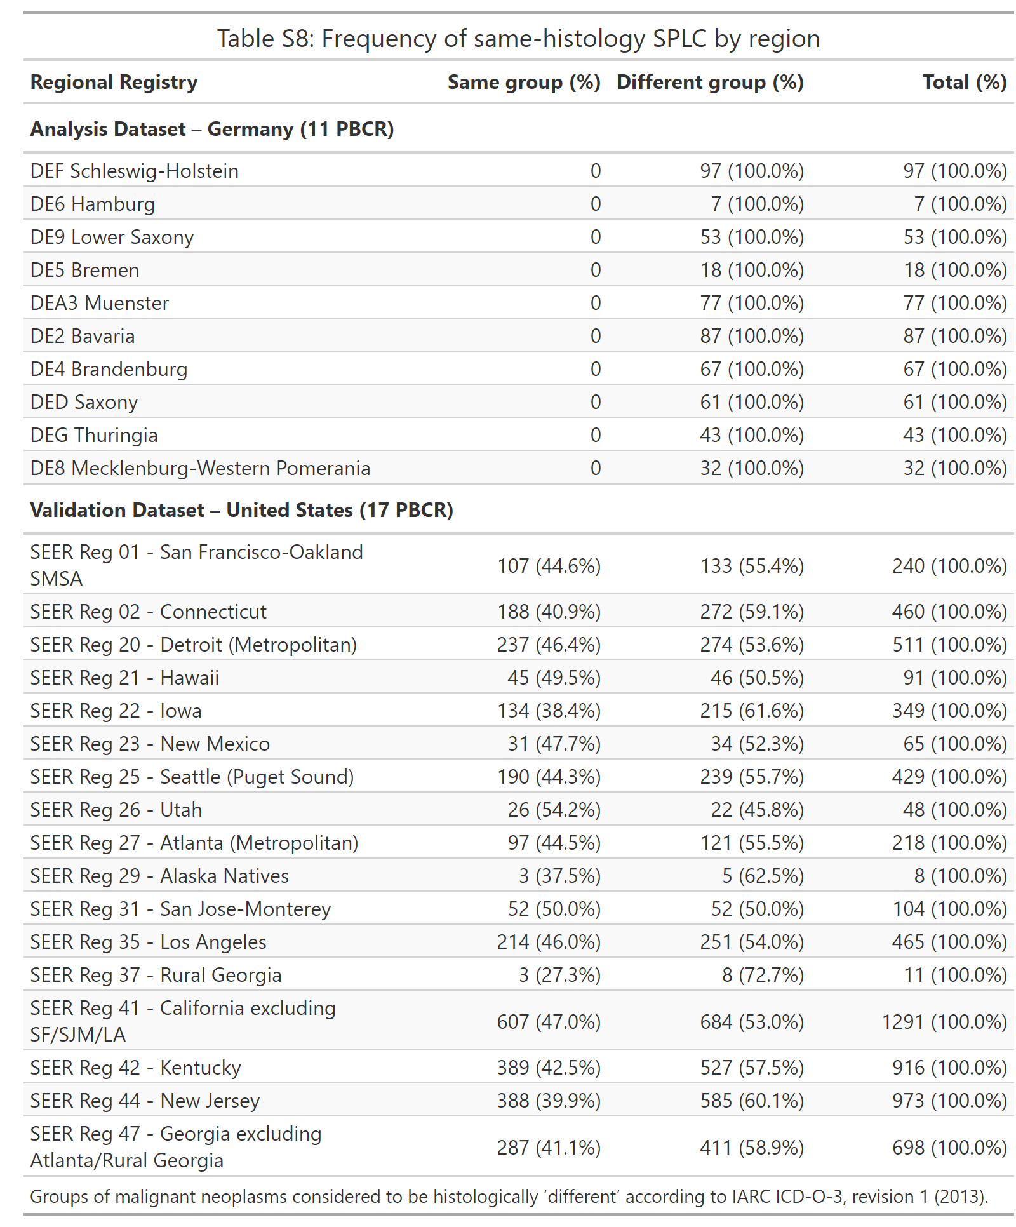

## Figure S9: Relative risk for SPLC in lung cancer survivors stratified by follow-up time

|  |
| --- |
| Figure 2 |

## Table S10: Sensitivity analysis A – Risk of SPLC using unadjusted and histology-specific SIR method [restricted to six German PBCR with low DCO rate]

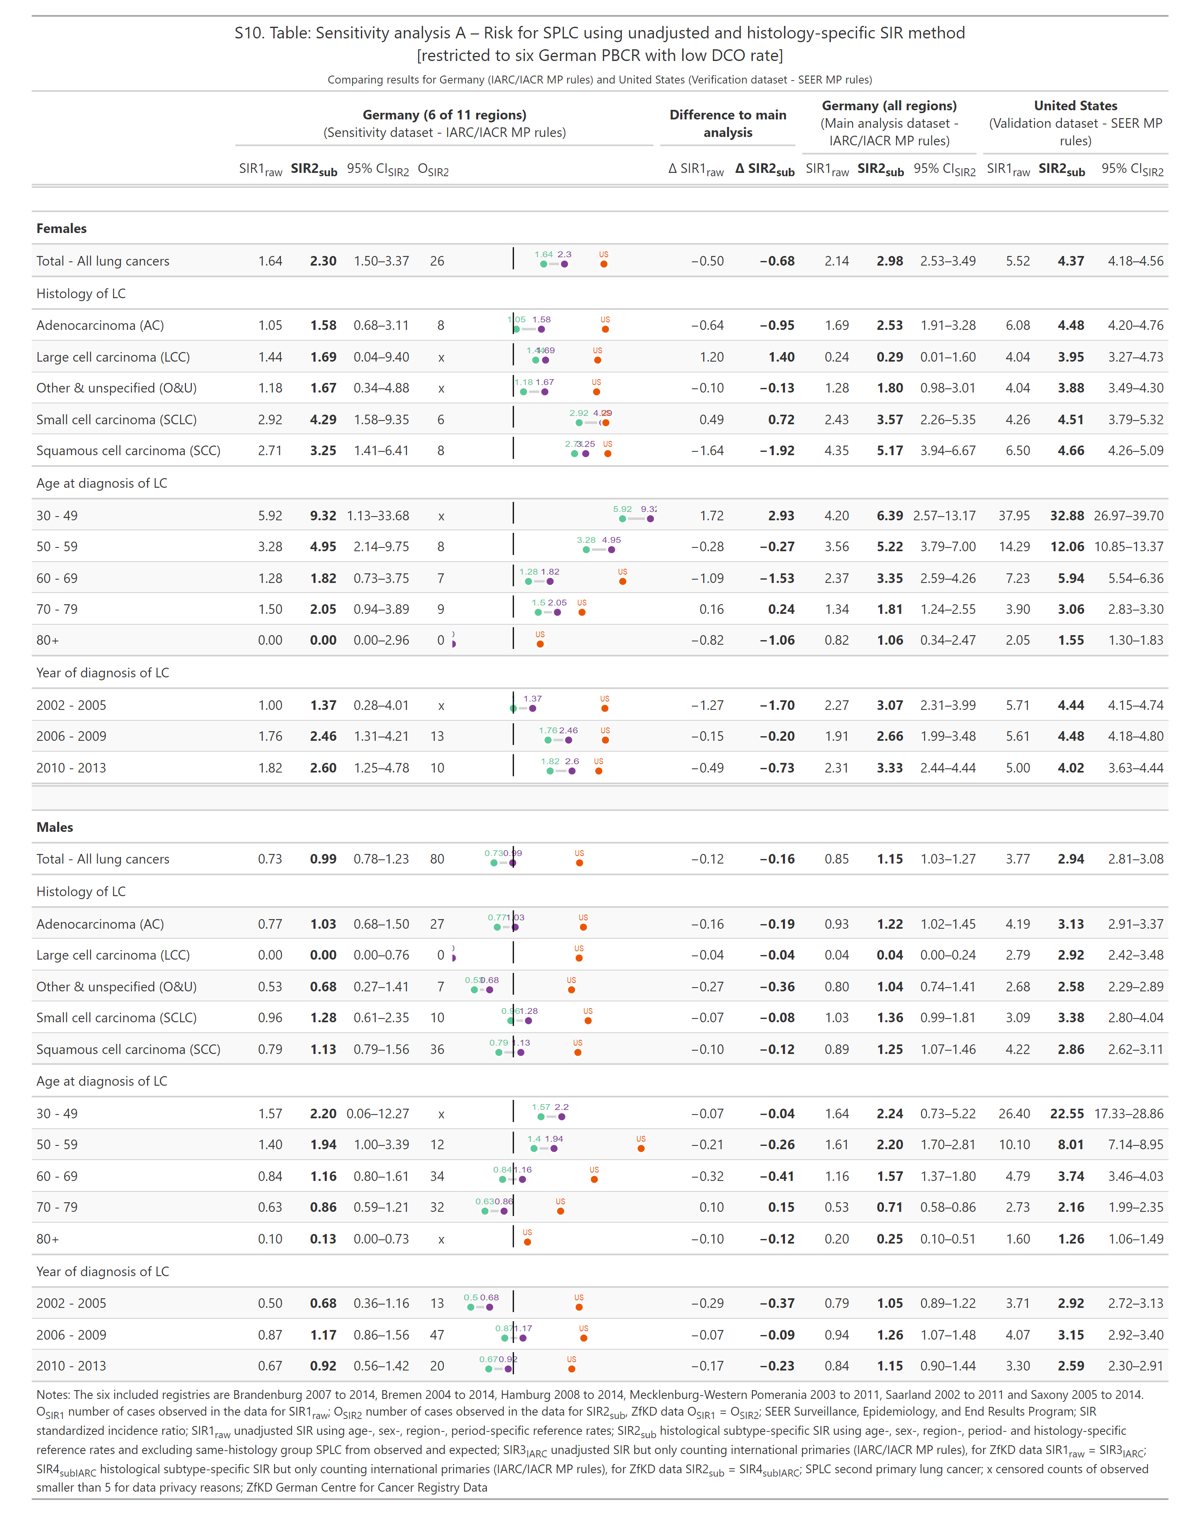

## Table S11: Sensitivity analysis B – Risk of SPLC using unadjusted and histology-specific SIR method [SEER restricted to White population]

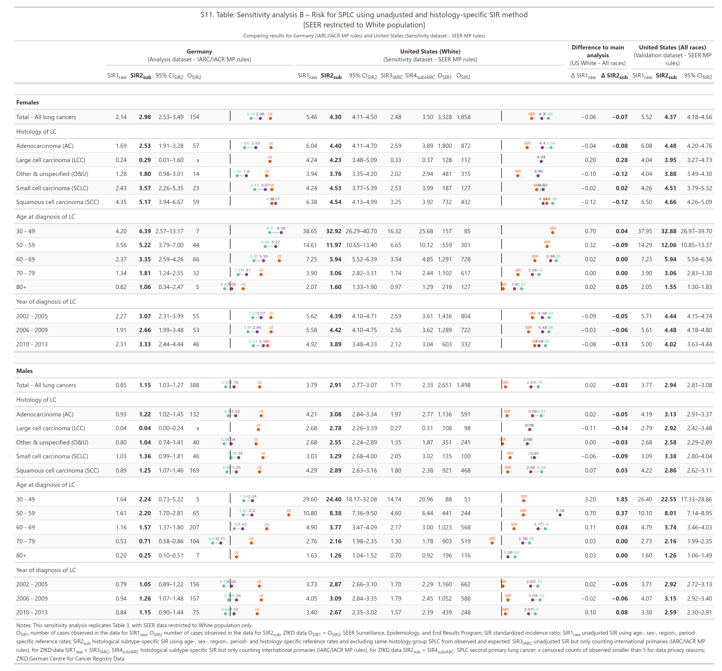

1. Thakur MK, Ruterbusch JJ, Schwartz AG, Gadgeel SM, Beebe-Dimmer JL, Wozniak AJ. [Risk of Second Lung Cancer in Patients with Previously Treated Lung Cancer: Analysis of Surveillance, Epidemiology, and End Results (SEER) Data](https://doi.org/10.1016/j.jtho.2017.09.1964). J Thorac Oncol. 2018;13:46–53.